1 // Test File Reads
2 // three different ways to read a file
3 // RoseS Feb 07
4
5 import java.io.*;
6 import java.util.*;
7 import javax.swing.JOptionPane;
8
9 public class TestFileReads
10 {
11 public static void main(String[] args)throws Exception
12 {
15 // One -- use a loop a definite number of times
16 Scanner infile = new Scanner(new File("testFileRead.txt"));
17 int[] one = new int[6];
18 for (int i = 0; i < 6; i++)
19 one[i] = infile.nextInt();
25
26 // Two -- use the first number in the file
27 infile = new Scanner(new File("testFileRead.txt"));
28 int numTimes = infile.nextInt();
29 int[] two = new int[numTimes];
30 for (int i = 0; i < numTimes; i++)
31 two[i] = infile.nextInt();
37
38 // Three -- read until the end of file
39 infile = new Scanner(new File("testFileRead.txt"));
40 int SOMENUM = 20;
41 int[] three = new int[SOMENUM];
42 int count = 0;
43 while(infile.hasNext() && count < SOMENUM)
44 {
45 three[count] = infile.nextInt();
46 count++;
47 }
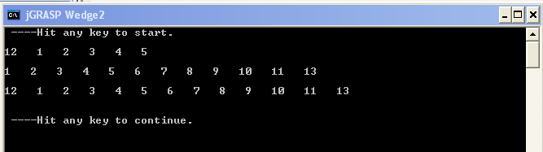

ThreeTextFileReads.doc

